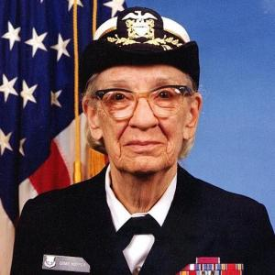

Awards:

Man of the Year Award  
Yale’s Wilbur Lucius Cross Medal  
National Medal of Technology

Degrees:

Undergraduate Degree in Mathematics and Physics from Vassar College   
Masters Degree and PhD in Mathematics from Yale University

Higher Education:

Vassar College   
Yale University

Contributions:

While at the U.S Naval Reserve, Hopper worked with Howard Aiken on the Mark 1, and wrote the user manual for it. She helped develop the Mark II and Mark III after the war, and later worked on the UNIVAC 1 and developed the first computer language compiler A-0.

Occupations:

Professor of Mathematics at Vassar College  
Rear Admiral US Naval Reserve  
Research Fellow at Harvard University  
Head programmer for Remmington Rand

Grace Hopper

December 9, 1906-January 1, 1992

Birthplace: New York City, NY, USA

Country of Origin: USA

Awards

Contributions